1. Create a directory called ""my_folder"", navigate into it, and create a file named ""my_file.txt"" with some text. Then, create another file named ""another_file.txt"" with some text. Concatenate the content of ""another_file.txt"" to ""my_file.txt"" and display the updated content. Finally, list all files and directories in the current directory.

Screenshot:

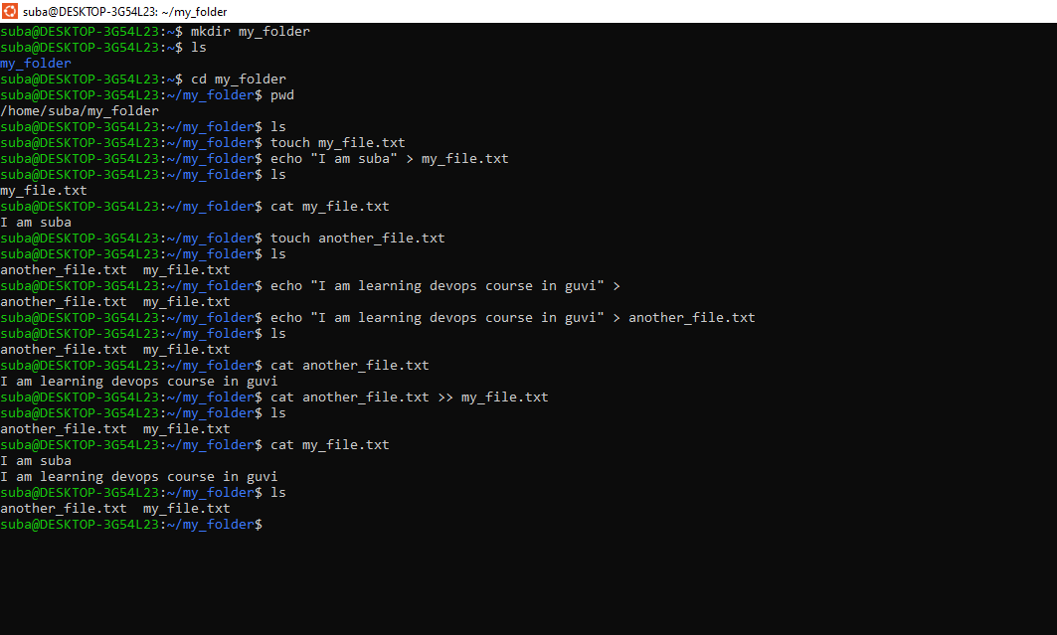

1. Create 20 files with .txt extensions and rename the first 5 files to .yml extension and Print the latest created top 5 files among the total no of files".

File created by using for loop and renamed by using for loop:

for i in {1..20}; do touch "file$i.txt"; done

for i in {1..5}; do mv "file$i.txt" "file$i.yml"; done

find . -type f -printf '%T+ %p\n' | sort -r | head -n 5

